Stadium Seat Booking

# Project Description:

In our world live tournament games are very popular. The people love to see the live matches. So these are in high demand in our society. At that time, organising the seats in the stadium was also very difficult because the organiser could distribute the seats to family and friends. So it creates a bad impact on the audience.

To overcome these we can develop one website, Stadium Seat Booking. Through this website people can book the stadium ticket at any place at any time. So the audience can book the seats with their preference. In our project we have three modules: Admin, GameHost, Audience. Game Hosts can add the sports schedule details like game title , number of teams, number of players in a team, game duration, start time date and end time date. The game host adds the upcoming game schedules and also adds the number of seats present in that stadium in different categories. So the audience can easily search the games and book the seats.

**Booking type is two ways one is couple booking and general booking. Couple booking means the couples can book the seats. At the time of booking two seats should be selected at a time. General booking means normal booking.One audience can book only 10 seats for one account. At that time the audience will receive the complimentary as food which they can see while booking the seats.**

Through this website the audience can book the seat and pay the amount. From that amount 5% of the amount will be transferred to the admin account and 95% of the amount will be transferred to the game host account.

Admin can login with predefined credentials. The admin can view the registered gamehost and the admin only can approve the gamehost accounts then only the gamehost can login. The admin can add seats to the added stadiums. All seats are not the same; the admin can divide the seats into different zones like Orchestra, Mezzanine and Balcony. Orchestra means the seats are closer to view, mezzanine means the seats are a little higher and balcony means top seats. In these zones again there are two types: couple type and general type.The admin does not add the price to the seat. The admin can view the added seats to the stadium. The admin can view the gamehost added game schedules. The admin can view the total bookings of the scheduled games.

The game host can register with their details and the game host can not login directly, when the admin can give the approval to their account,then only gamehost login to their accounts. The game host can add the upcoming games schedules, in this only game host can choose the admin added stadiums and select the wanted stadium with the available seats for the couple and general audience, a seat has attributes like seat label, price per seat like different seats have different prices this is added by game host only, complimentary food details, then the host will publish. While the game host before adding the game schedule they check other sports schedules also because there should not be any other game schedule at the same time.

To check this we will use the datetime functions. By doing this we can avoid the time conflict from one game to another game. The game host can view the added games schedule. The Game host can and the game host can view the bookings.

The audience can login with their email and to that email they will get OTP. then they enter the OTP and login to the website. The audience can view the upcoming games and also available seats for those games. The audience can book up to 10 seats with Audience details. Then the audience also can view the bookings and also the audience can cancel the booking before the game starts. The audience also has the option to transfer their booked tickets to others.

**Database description:**

In the Stadiumticket booking system we have seven database collections. Admin have default login credentials. Admin will login and add stadium name, stadium type which means indoor, outdoor or open air, stadium location and address. This data of the stadium will be stored in the Stadium collection. Admin add time slots for the stadium. The time slot collection contains the timeslot_Id, date and time, status for defining the availability of the time slot. stadium_Id is the reference key from the stadium collection to represent the stadium. Game organiser will register in order to log into the system. The registrations of each game organiser will be stored into the GameOrganiser collection with game organiser’s name, email, phone, address, password, accout_status, picture. Game organisers profiles will be verified by the admin. The account_status of the game organiser will be inactive or not verified by default until the admin approves the game organiser. Game organiser will login after his account is activated and add the game schedule. The schedule collection contains the games and their scheduled timings in it. The Game Organiser adds the game schedule based on the time slots available in the stadium. The schedule collection contains gameTitle, no_of teams, no_of_players in a team, game duration, timeslot_Id is reference key here to represent the time slots and gameOrganiser_Id to represent the game organiser who organises the game. The Game Organiser can only select a time slot only when the status in time slot collection is available. stadium _Id and Game organiser_id are the reference keys in this table. Tickets collection contains the data about the tickets for a game. It is based on the game schedule because the seat price will change based on the game. Is_coupleseat is a feature which book seats for couples, price per seat, complementary food. This collection contains a schedule_Id reference key for representing the schedule of a game. Audience will login with OTP and can book the tickets for that they have to enter their email and phone. Audience collection stores this name, email, phone and Id of the audience. When Audience book a ticket, the bookings details will be stored in the Bookings Collection. It contains audience_id which represents the person who booked the ticket, ticket_Id, seatNumbers, booking status, and booking date. The booking status will change into booked when the payment is done.

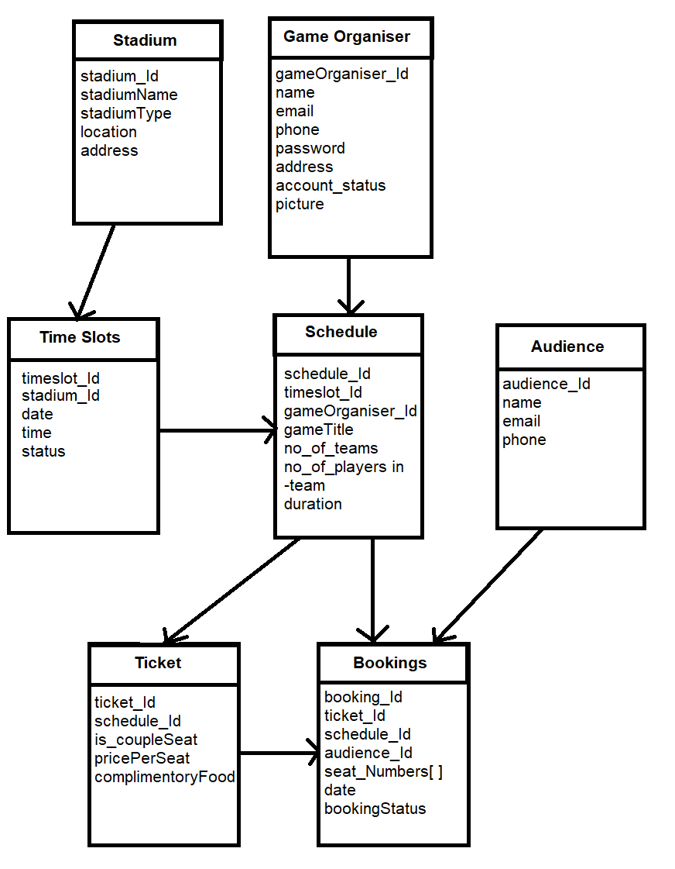

**DATABASE COLLECTIONS:**

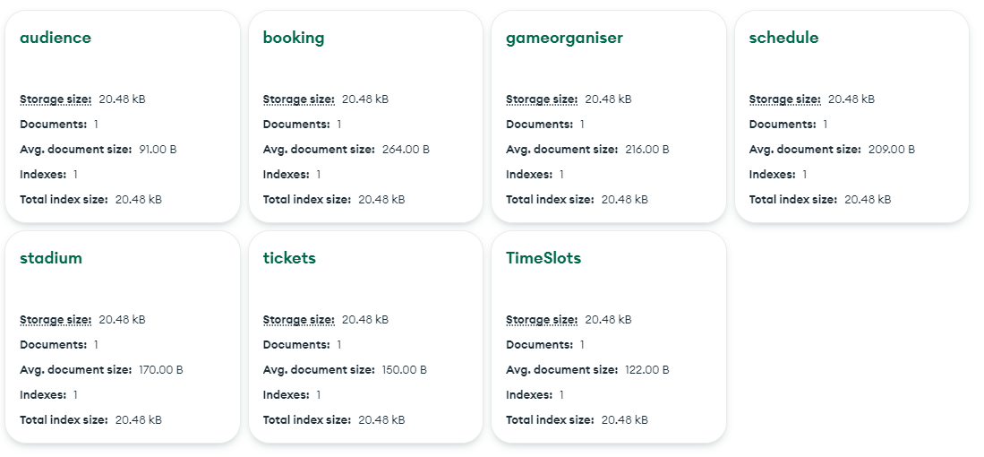

**SAMPLE DATA:**

Stadium:

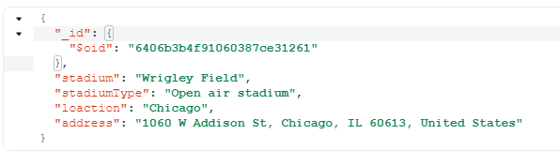

GameOrganiser:

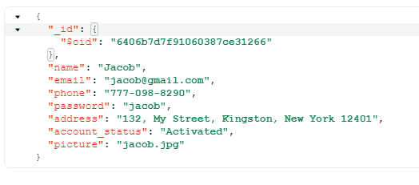

Time Slots:

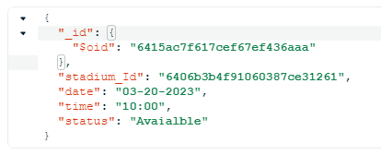

Schedule:

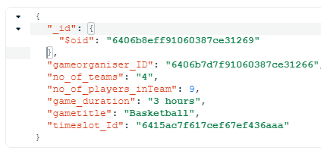

Tickets:

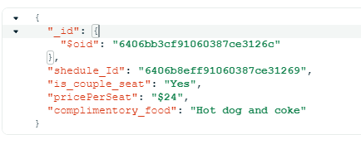

Audience:

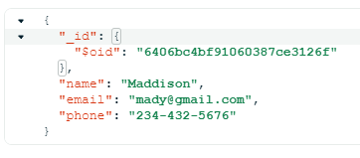

Booking:

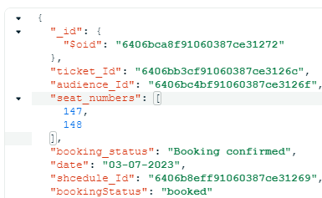

**Functional Requirements:**

* Admin will login with default login credentials.
* View Game Organisers and do activate or deactivate the Game Host
* Admin add stadium by giving its name and address details
* Admin can view the added stadium and can update its details
* Admin add time slots for the games play in the stadium
* Admin can view the time slots added
* Game Organiser will register and can login after verified by the admin
* Game Organiser View time slots and book the time slot for a game
* Game Organiser view the game schedule, Add tickets and define the is couple seat or not
* Game Organiser can view the ticket details and can view the booking made by the customers
* Audience login with Email and OTP verification
* Audience can view game schedule and book ticket
* Audience can select couple seat or non couple seat
* Audience can pay amount and confirm booking
* Audience can view their booking and can cancel and transfer the ticket

**User Interface Forms:**

* **Adminloginpage.html:** In this admin will login
* **oragniserReg.html:** In this page organiser will register
* **OrganiserLoginpage.html:** In thispage game organiser will login
* **Audientloginpage.html:** In this page audience will give email for login
* **Audienloginpage1.html:** In this page audience will enter otp
* **Addstadium.html:** In this page admin will add the stadium details
* **Addtimeslots.html:** In this page admin will time slots in this page
* **addTickets.html:** In this page admin will add the tickets
* **bookTickets.html:** In this page audience will book ticket
* **addGameschedule.html:** In this page Game organiser will add the game schedule
* **Payamount.html:** In this page audience will pay the ticket amount

**Admin Login:** This is the admin login page. Admin will login with default username and password

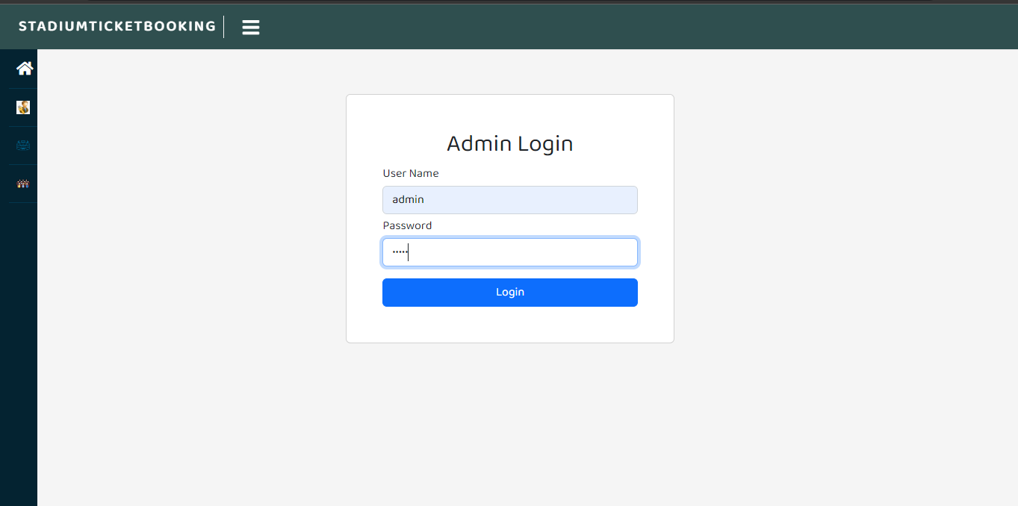

**Game Organiser Registration:** This is the Game Organiser registration page. Game organisers register by giving their name, email, phone number, password, picture and address.

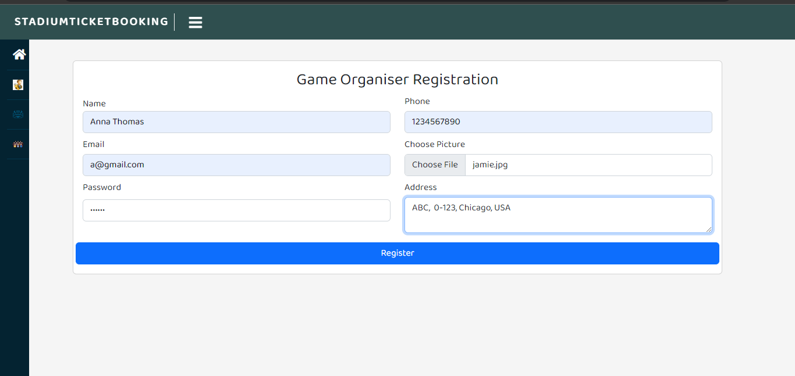

**View Game Organisers:** This page displays the Game organisers who have registered. Admin can activate and deactivate the Game Organiser

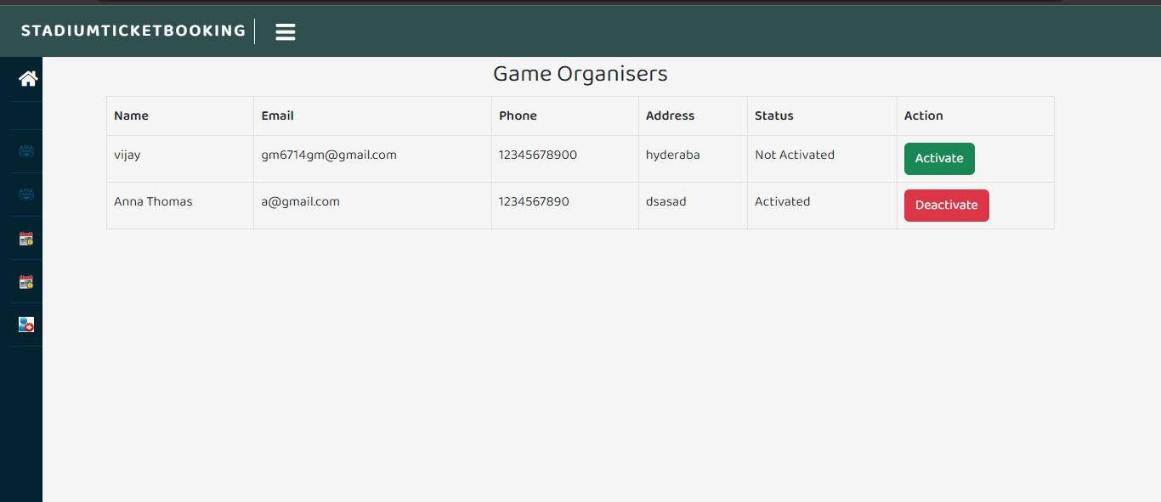

**View Stadium :** This page displays the stadium details. Admin can update the stadium details by clicking on the Update button

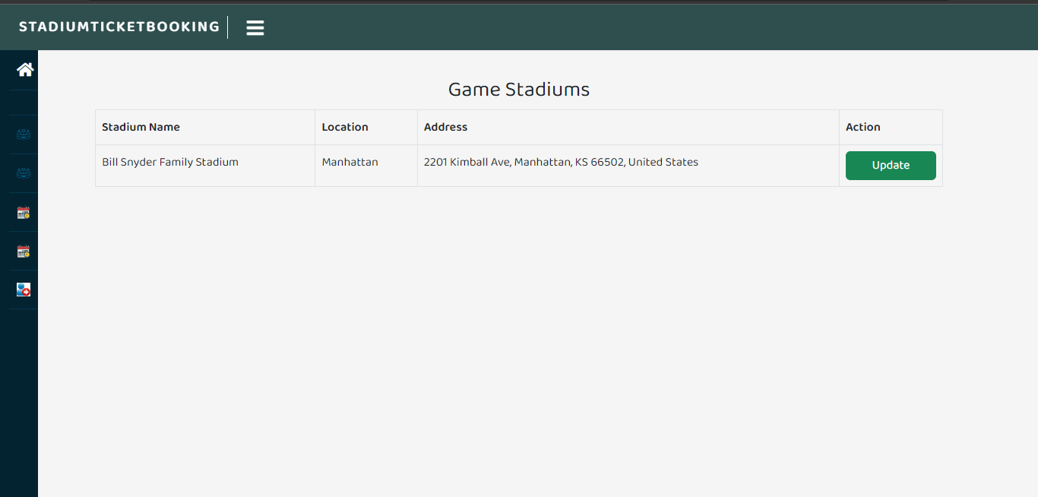

**Add Time Slots:** In this page admin will add the time slots

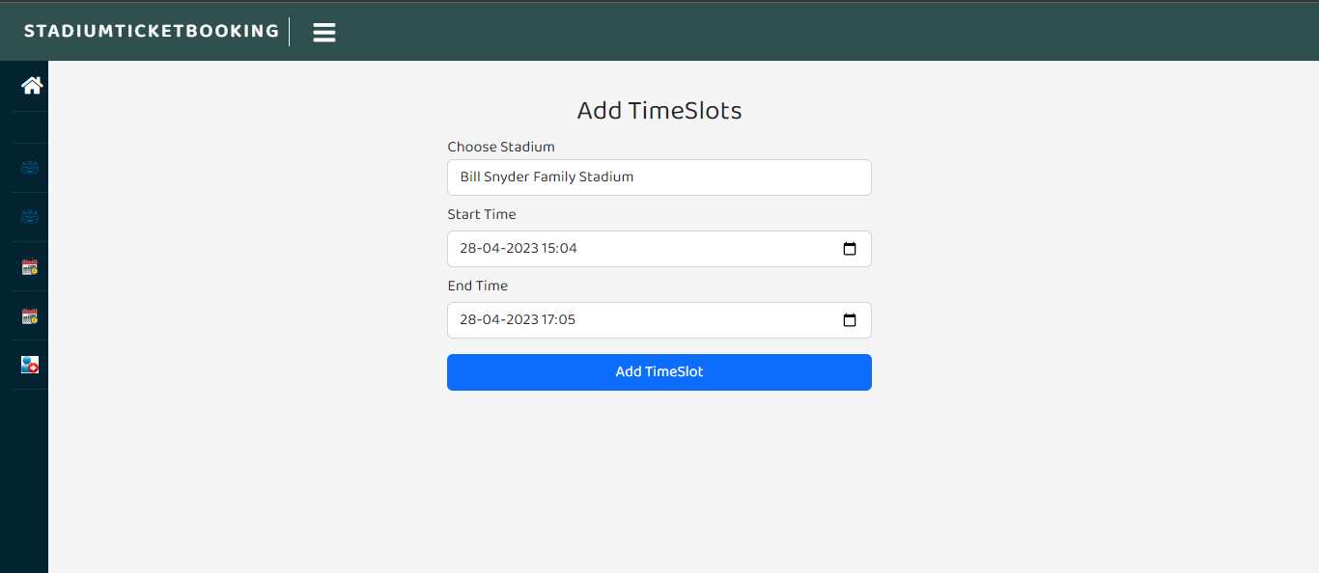

**View Time Slots:** This page shows the time slots which are added by the admin

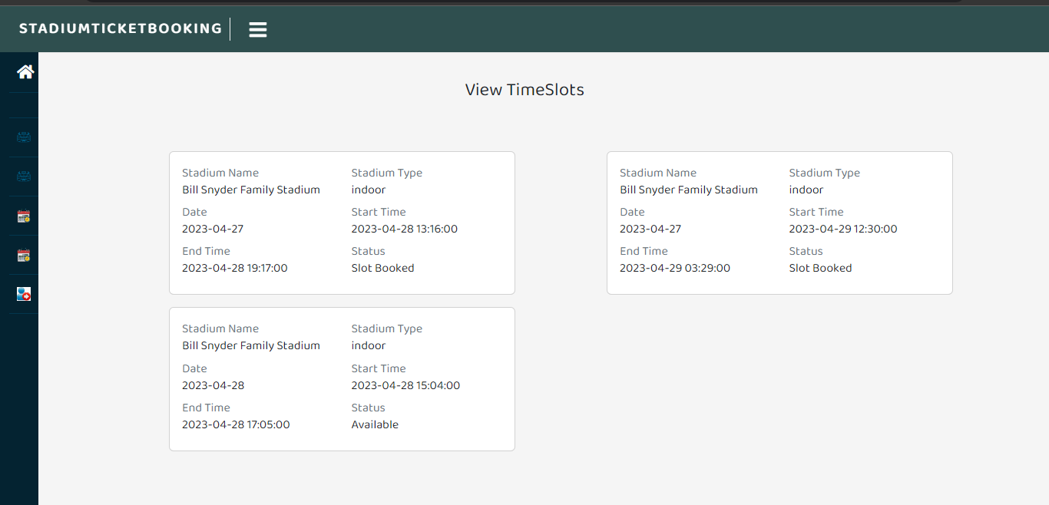

**View Time Slots:** After login, The game organisers view the available time slots. They can book the time slot by clicking on the Book slot button

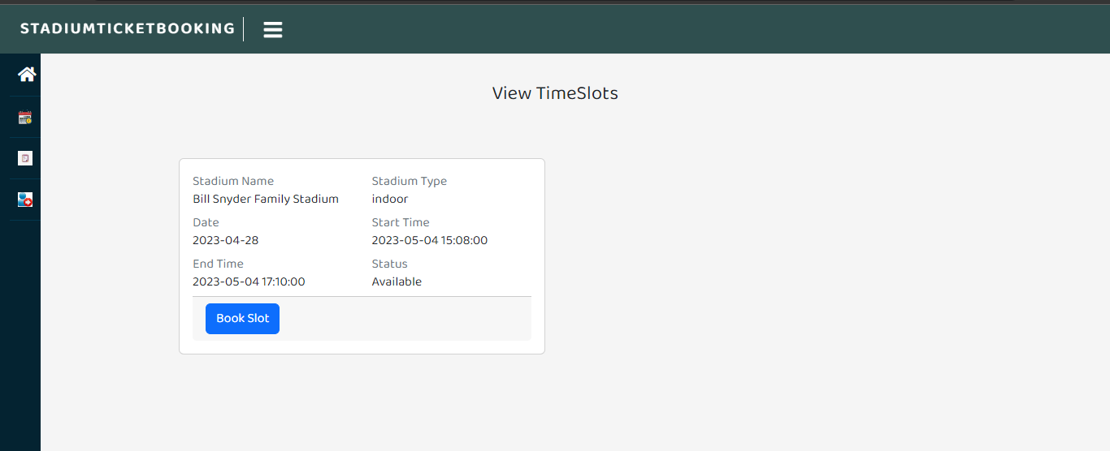

**Add Game Schedule:** This is the add game schedule page. Game organiser will add the game schedule by giving game name, indoor game or outdoor game, no of teams, no of players in a team and game duration.

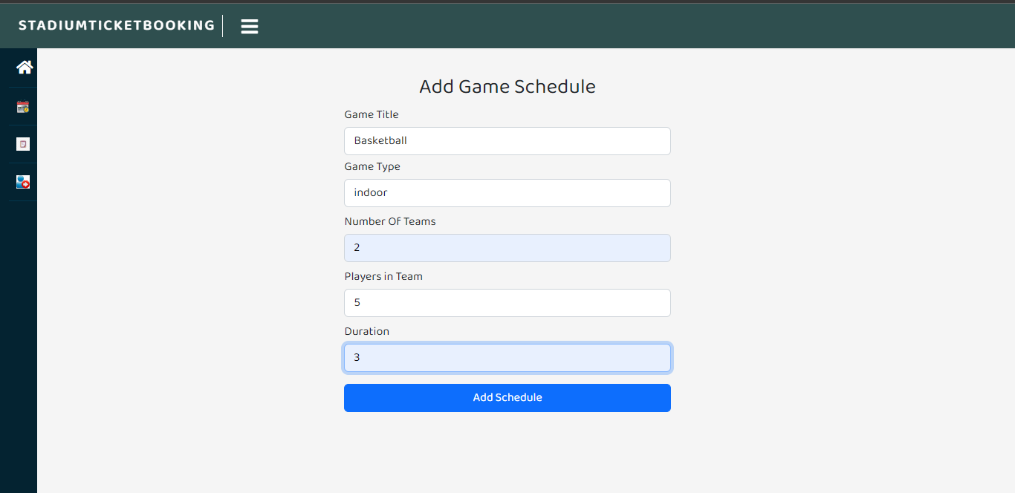

**View Game Schedules:** This page will display the game schedule. Game organisers can add tickets for this game by clicking on the add tickets button. And also game organiser can view the tickets which are added by clicking on the view tickets button

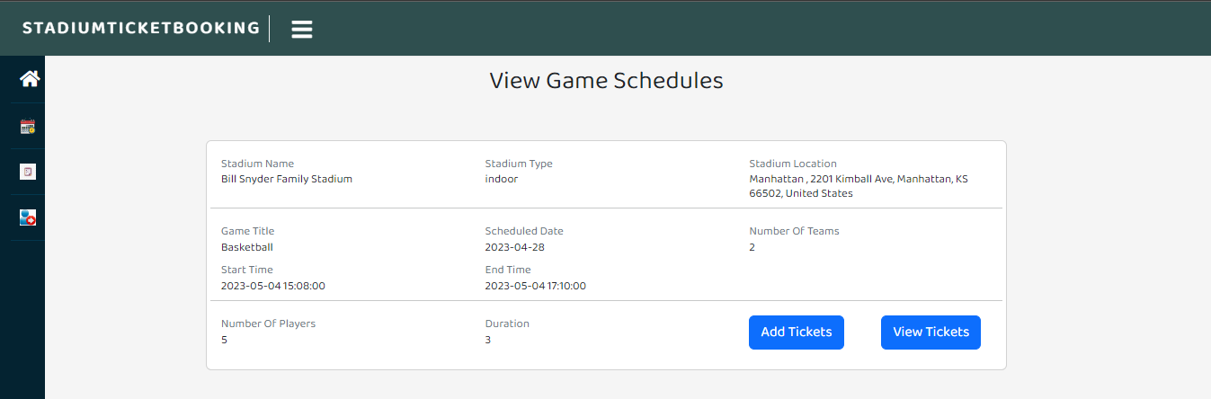

**Add Ticket:** In this page the game organiser will add the ticket price, no.of tickets, is couple seat or not complementary food

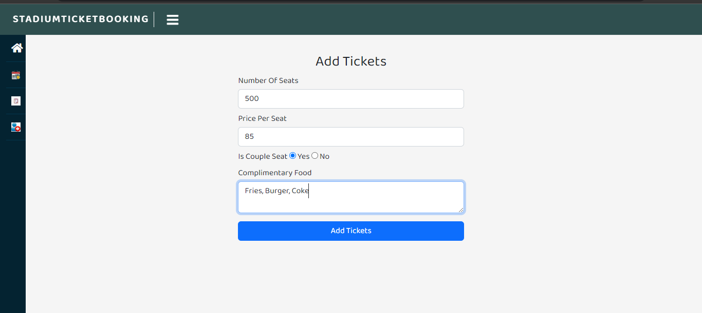

**View Tickets:** This page displays the ticket details. Game organiser can view the bookings made on these tickets by clicking on the view bookings button.

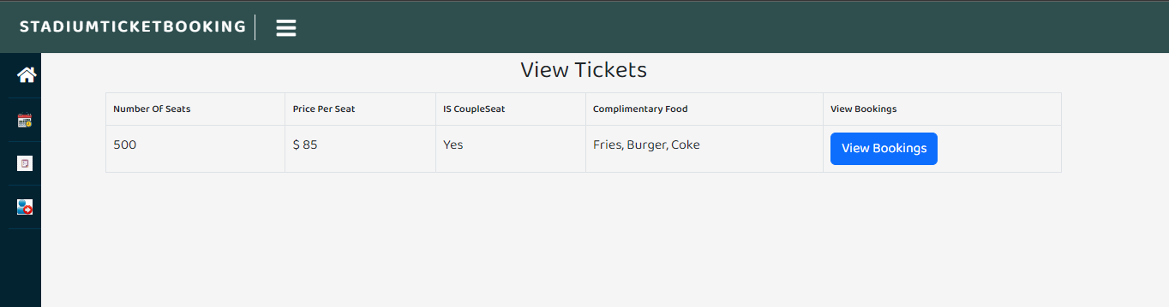

**Customer Login :** In this page the audience will enter their email address to get registered or login.

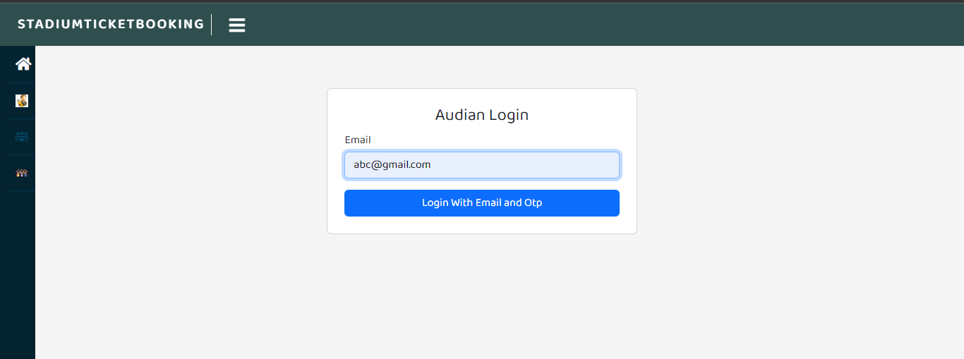

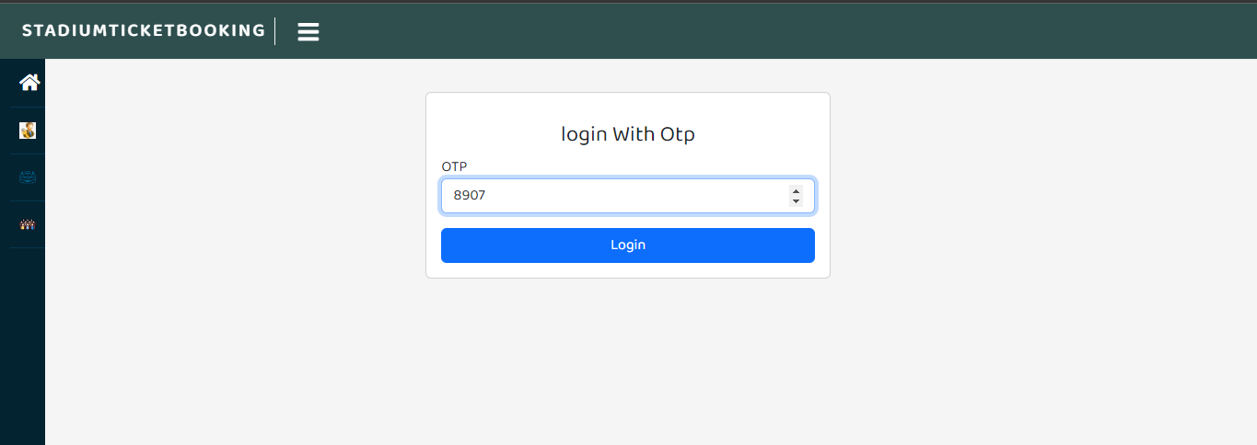

**View Game Schedule:** This page displays the game schedule details. Audience can book tickets by clicking on the BOOK TICKETS button.

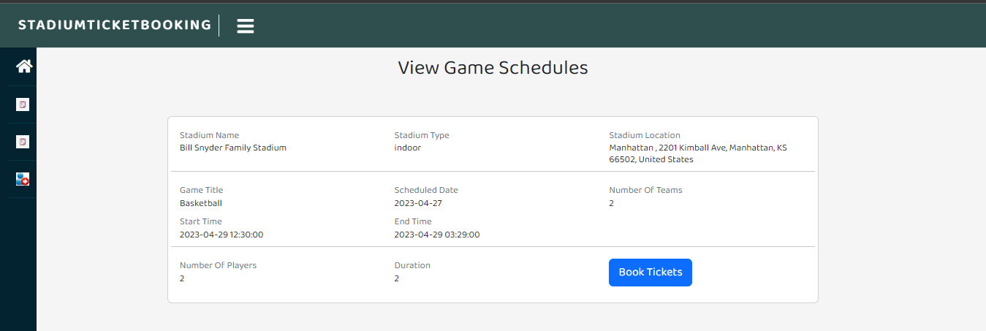

**Select Seats:** This page is the stadium seating layout page. In this Audience can select a couple seats. Yellow colour indicates the available seats and red colour indicates allocated seats.

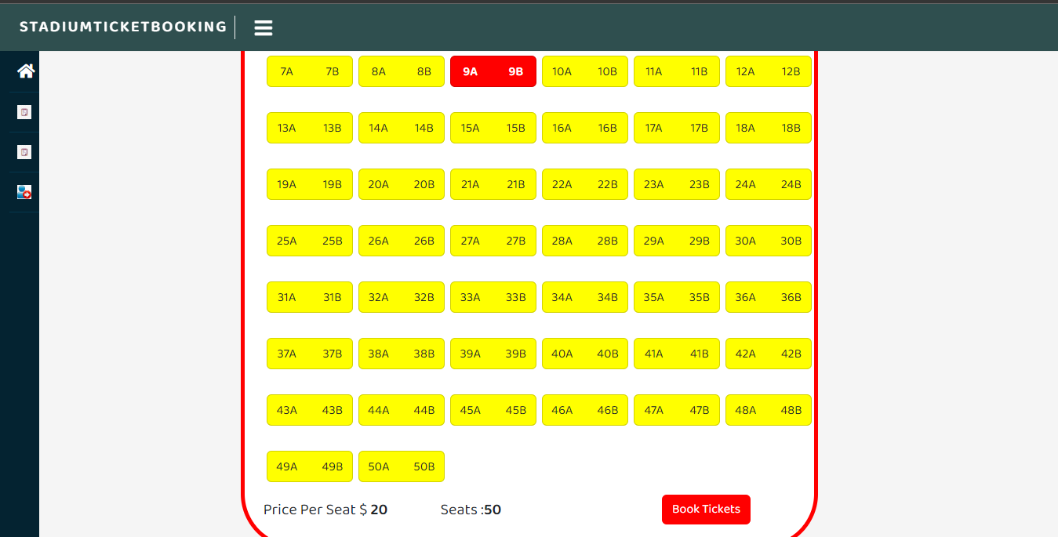

**Ticket Summary:** This is the ticket summary page. In this page the audience can see the game schedule they have selected, price of the ticket and seat number.

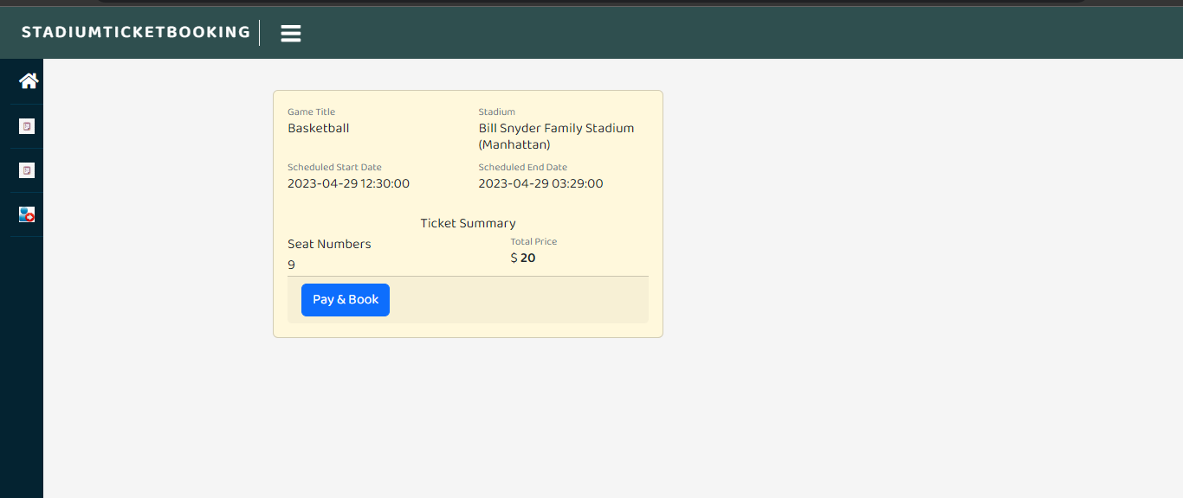

**Payment :** In this page the audience will enter their card details and pay the ticket price.

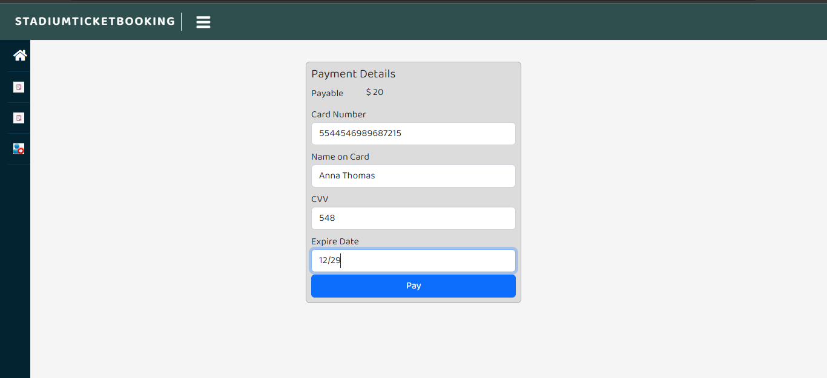

**View Bookings:** This is the bookings page. Audience can cancel and transfer tickets by clicking on the respective buttons

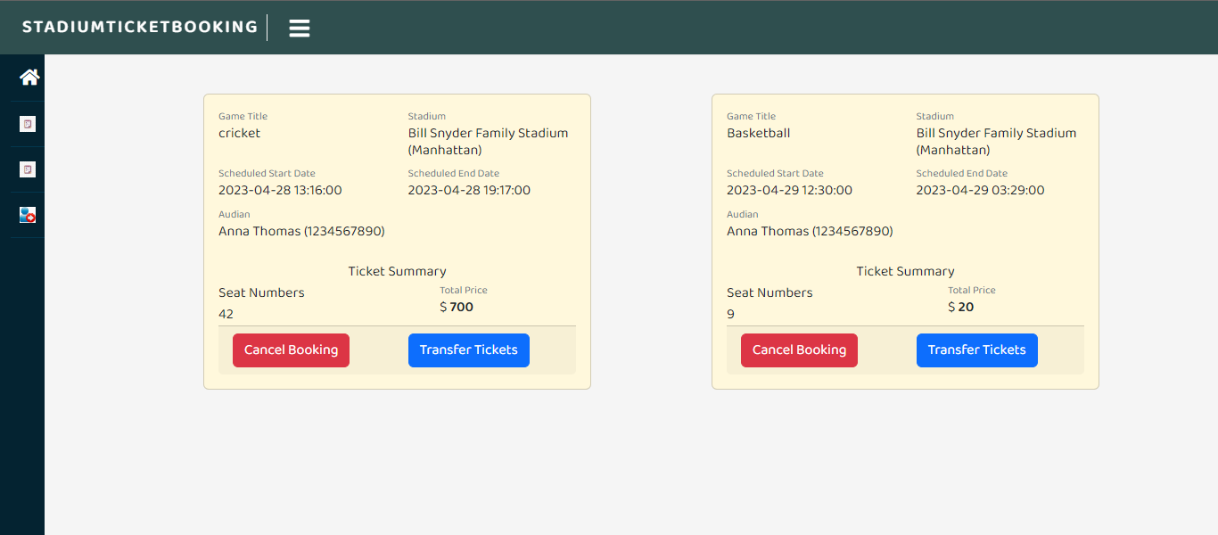

**View Bookings :** This view bookings page in game organiser module. This page displays the name of the audience, price of the tickets and seat numbers.

